
Intravenous (IV) Antibiotic Treatment at Home
Information for patients

Royal Infirmary of Edinburgh

Bronchiectasis Out-patient IV Antibiotic Service

Contact details:
Respiratory Nurse Specialist (Bronchiectasis Lead): 0131 242 1878
Ward 204: 0131 242 2044/242 2041
Royal Infirmary of Edinburgh: 0131 536 1000

Introduction
This leaflet provides some general information about intravenous (IV) antibiotics used to treat bronchiectasis at home. More detailed information will be provided by the Respiratory Nurse Specialists.

The Outpatient IV Antibiotic Service
The service is made up of a consultant doctor, respiratory nurses and pharmacist. We have a bronchiectasis lead nurse as well as respiratory nurses who provide support seven days a week.
They will provide you with all the teaching, information and support that you require to allow you to receive IV antibiotics at home. This prevents a prolonged stay in hospital. Out of hours support is provided by Ward 204 doctors and nurses.

Why do you need antibiotics?
In bronchiectasis, the lungs are more prone to infection because of the collection of thick mucus. It is important to reduce mucus by doing physiotherapy.
Antibiotics are also used to treat chest infections and the sooner the infection is treated, the sooner you will feel better and there will be less damage to the lungs.

What are IV antibiotics?
Antibiotics are medicines, which kill bacteria or stop them from growing. They help the body to fight bacterial infections.
Intravenous (IV) antibiotics are administered directly into the vein and are more effective for specific infections. IV antibiotics are used when oral antibiotics have not been effective, or the bacteria are resistant to oral antibiotics.
A midline catheter or small narrow tube (cannula) will be inserted into the vein in your arm to allow the administration of these antibiotics. A more permanent device called an implanted port can be inserted. This is a planned procedure performed in the day surgery unit. This would only be inserted if you were having regular intravenous antibiotics.

How does the doctor choose which antibiotics to use?
Samples of sputum will be taken and cultured (allowed to grow in a laboratory) to find out which bacteria are causing the infection. Several antibiotics are tested to see how effective they are against the bacteria and the most suitable will be chosen.
The doctor will prescribe which antibiotics you are to receive, and the nurse will supply them.

Advice on using antibiotics
The nurse will provide you with information about the antibiotics.
Antibiotics are usually administered for 14 days. It is important to finish the course of antibiotics. If you stop early, this may leave a reservoir of infection. Let the nurse know immediately if you have had to stop using your IV antibiotics.

What teaching and support will I be given?
When you have your first course of IV antibiotics you will be carefully taught how to prepare and inject them. There will be plenty of opportunity for you to practice and this will be supervised. You will also be given instruction leaflets to take home with you. If a family member or friend is helping you to administer the antibiotics at home, they will be provided with this help too.
You will be assessed while preparing and administering the IV antibiotics to ensure you are competent and safe to administer the IV antibiotics at home. The nurse assessing you will sign a competency form, and you will also sign the form to say you are confident to self-administer IV antibiotics.

How do I prepare IV antibiotics?
- When you are prescribed a course of IV antibiotics you will be supplied with:

Vials of the antibiotic
This will either be in powder form, which has to be dissolved in the water for injection, or in liquid form ready to inject.

Water for injections
This may be needed to dissolve the antibiotic powder in the vial.

Sodium chloride for injection (saline)
This is injected into the tube in your arm between antibiotics to keep it clear.
You will also be supplied with all the equipment required to administer the antibiotics, e.g. sterile spikes, syringes, sterile wipes and a sharps bin.
- It is important to check the names, doses and expiry dates of all the drugs prior to their preparation and administration. Check that all the packing on the sterile equipment, such as needles and syringes, is intact and not damaged.
- When preparing your IV antibiotics it is important to use a clean area that is easily washed down with detergent and water, e.g. a kitchen worktop.
- Thoroughly scrub your hands with soap and water before you begin. Minimise sources of germs during the procedure by keeping pets out of the room and avoiding housework such as dusting prior to the injection.
5. Always use the ‘no-touch’ technique when preparing the antibiotics.
- Never touch the ends of the spike, the nozzles of syringes, plunger of syringes, tips of rubber bung, necks of ampoules.
- If you think you may have contaminated the needle, syringe or vial during the procedure (by touching or dropping it) then discard and start again.
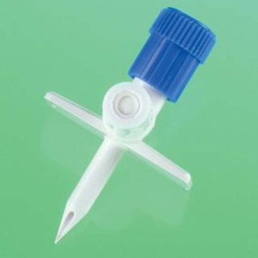
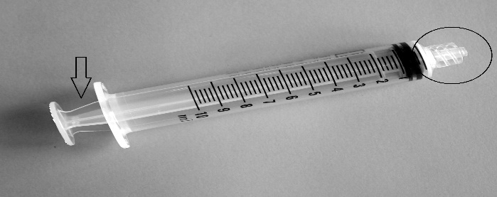

How do I give IV antibiotics?
The IV antibiotics are administered by using a syringe filled with the antibiotic, which is attached to your cannula/midline or port. The IV antibiotic is pushed slowly into the vein. The vein is always flushed with sodium chloride before and after administering the IV antibiotic.
If you have an implanted port, heparin sodium is always administered last to prevent a clot forming in the line.

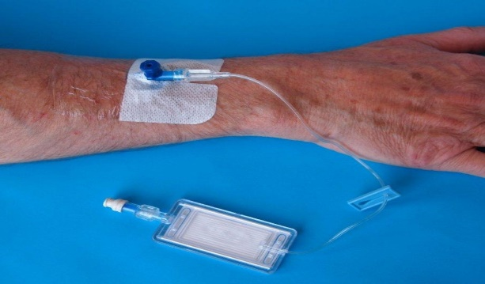
Cannula
The cannula (small narrow tube) is placed in a vein in your hand or arm and is used to administer the antibiotics. An extension set will be attached to the cannula to help with administering.
The nurse will insert this, and it may need to be replaced every three days. The nurse will give you dressings to cover the cannula when it is not in use. It will be removed when the course of antibiotics is completed.
When your cannula is in place remember to:
- Avoid touching cannula
- Take care when removing clothing and other activities
- Keep the cannula dry and the dressing in place
- Observe the cannula site for signs of redness, swelling pain, burning or discomfort. If any of these symptoms are present, do not administer your antibiotics. Contact the hospital. Phone the bronchiectasis nurse during office hours and ward 204 out of office hours.

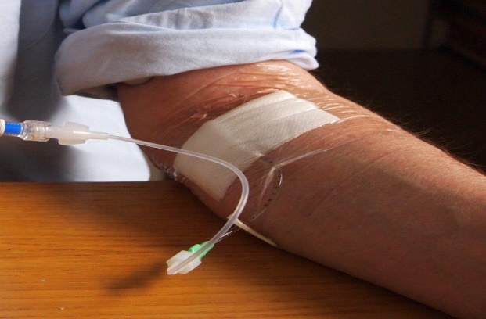
Midline Catheter
A midline catheter is inserted into a vein in the inside of the elbow and extends into the vein of the upper arm.
The benefit of a midline is that it can stay in the arm throughout the treatment, which preserves other veins and removes the need for replacing cannula’s every three days.
The midline will be secured with a fixator dressing and covered with a clear dressing. The dressing will require to be changed every 7 days or more frequently if there is leakage.
Always clean the hub thoroughly at the end of the midline for 10 seconds and allow to dry for 30 seconds before using line. Always use the clamp - opening the clamp before administering each syringe and closing the clamp after syringe is emptied.
The extension set which is attached to the line, will need to be changed weekly by a nurse.
When administering antibiotics via the midline, the push/pause technique is used to create a pressurised flush which prevents a blockage in the catheter. Sodium chloride flush is always given before and after antibiotic. Always administer antibiotic slowly over 3 minutes and sit down while administering.

Care of midline catheter
- After the midline is inserted, maintain the arm in a straight position for 30 minutes to avoid kinking of the catheter
- Contact the Respiratory Nurses if there is excessive bleeding on the dressing. If this happens, you will have to attend the hospital to have the dressing changed
- Avoid touching the dressing
- Try to keep dressing as dry as possible, cover with a plastic bag/cling film and tape while in the shower
- Examine surrounding areas for signs of redness, swelling, leakage, pain or discomfort and do not give antibiotics if any of these occur
- Do not give antibiotic if there is a blockage in line and contact the hospital if this occurs.

Possible complications
Although infrequent, there are a few complications that can occur. These include:

Blocked IV line
This is when it becomes impossible to push the contents of the syringe into the midline catheter. Although this should not happen if the line is always flushed through both before and after the antibiotic has been administered, it does occasionally occur.
Always finish with sodium chloride and clamp under positive pressure. Do not force the plunger of the syringe and do not attempt to remove the dressing as this may dislodge the midline. Contact the hospital if a blockage occurs.

Dislodged midline
Although extremely unusual, if an event occurs which causes the line to become dislodged, e.g. catching the line on something during your daily activities, apply pressure on entry site for five minutes using a clean swab and elevate arm. Apply plaster or similar dressing and contact the hospital.
Ensure dressing is kept dry as a wet dressing can cause line to dislodge.

Leakage from connectors or entry site of midline catheter
Tighten the connectors around the extension line and the cap where the syringe attaches to. Contact the hospital if any leakage occurs.

Implanted Port
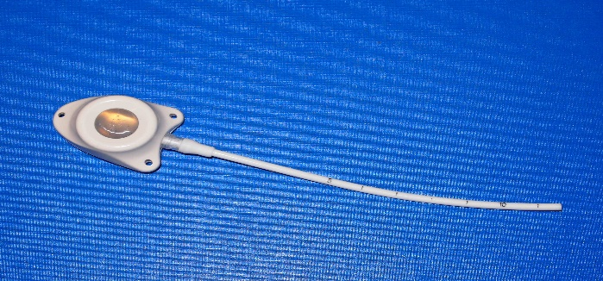
An implanted port is a small device that is inserted under the skin, with a catheter attached, which connects the port to a vein. The port has a septum through which the antibiotics are injected.
The port is inserted in theatre under a local or general anaesthetic. To access the port, a needle with a line attached is pushed into the port and secured with a dressing. This is removed when the treatment is finished.
The port can stay in place for many years and is suitable for patients who are on regular 8 to 12 weekly antibiotics.

Storing your antibiotics and equipment
Keep all of your medicines in a cool, dry place away from sunlight. Make sure medicines are safely locked away from children and be careful to store your unused needles and syringes safely.
A yellow sharps container will be given to you to dispose of the used spikes, syringes, and glass vials. Ensure orange lid is securely attached to yellow bin before using sharps bin. All paper and cardboard paper packaging can be disposed of in an ordinary household rubbish bin.

What are the side-effects of antibiotics?
Tell the respiratory nurse if you have any drug allergies, particularly to antibiotics.
Occasionally, some people develop an allergy to antibiotics, especially to penicillins. Usually the allergy is no more than an itchy rash but very rarely, people can have a serious reaction (known as anaphylaxis) when using antibiotics. This can even happen with an antibiotic that has been used many times before. The first signs are usually tingling and swelling of the lips and tongue, which can lead to swelling of the throat, chest tightness and difficulty with breathing.
Anaphylaxis is uncommon and usually happens with the first dose of a course of IV antibiotics. This is why we give the first dose in the treatment room and observe you for an hour afterwards.
If you experience anaphylaxis symptoms, contact the emergency services by dialling 999. As an extra precaution we will give you an ‘Epipen’ and instructions on how to use it. This ‘Epipen’ helps slow the symptoms of anaphylaxis until the ambulance arrives.
If you have any rashes or other strange effects from your antibiotic treatment, please inform the Respiratory Nurses immediately. Tobramycin or gentamicin can occasionally affect your hearing and can cause dizziness. Please let us know if you experience this side effect.
You will be given enough supplies for one week and an appointment to return in one week for blood tests and dressing change.

Contacting us
If you have any problems on Saturday or Sunday between the hours of 08.00 – 16.00, please phone Respiratory Nurse Specialists on 0131 242 1878.
If you experience any problems administering the dose late in the evening omit (do not take) the dose of antibiotic and contact Respiratory Nurses in the morning on the number above.
In the absence of respiratory nurses, please contact Ward 204 on 0131 242 2044 / 242 2041 and ask for nurse in charge to contact the Respiratory Registrar on call.
All supervised practise must be signed on the sheet overleaf. The patient or carer must have completed at least 3 practise sessions before being assessed as competent.

If you have any questions, please write them down here.

This will remind you to ask them when you come in for your appointments:

Patient name:
Practise sessions | Date | Patient/carer sign | Nurse sign
1
2
3
4
5
6
7

Training Checklist for Home IV Antibiotics
 | Date discussed  &  name of nurse | Date practised  &  name of nurse
Explanation of therapy
Hand hygiene
Storage and disposal of equipment
Competency in checking drugs
Competency in reconstituting drugs
Competency in administering drugs
Competency in disposing safely of equipment
Discussion of side effects and action to take
Discussion of vascular access device
Arrangements made for follow up care
Patient has phone numbers

