
How to self-administer IV antibiotics using a midline catheter
Information for patients
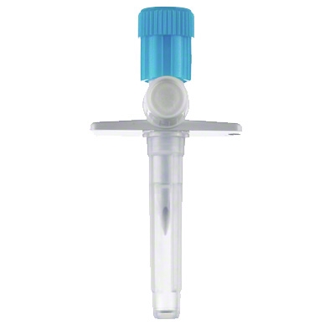
- Hands should be thoroughly washed with anti-bacterial soap before commencing procedure.
- Make sure work surfaces are thoroughly wiped with antibacterial wipes. Plastic tray or worktops are ideal.
Don’t touch key parts
- When attaching a spike to a syringe it is very important not to touch the key parts to avoid contamination.
- Do not touch either end of the spike or the tip and plunger of the syringe.

Contact
Respiratory Nurse Specialist Office: 0131 242 1878
Ward 204: 0131 242 20412

Preparing Sodium Chloride Flush

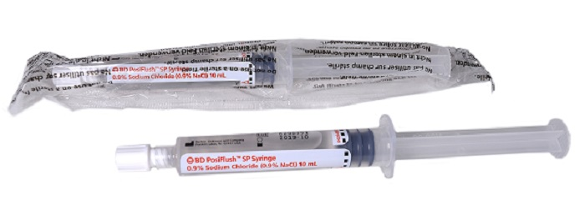

- Open packet of 10ml sodium chloride 0.9% posiflush
- Push plunger to release seal while cap is on
- Open white cap slightly and expel air
- Close white cap
- Lay down syringe

Preparing Antibiotic

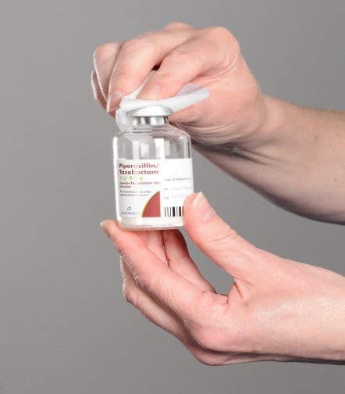
- Lay out pre-filled sodium chloride syringe, 20ml/10ml syringe, antibiotic, water for injection, spike
- Remove plastic seal from antibiotic
- Swab rubber top of the vial with alcohol wipe

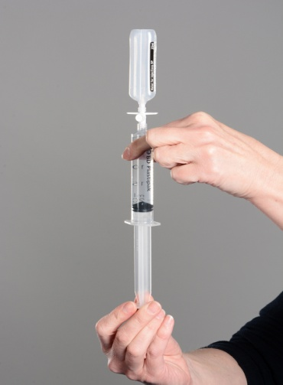
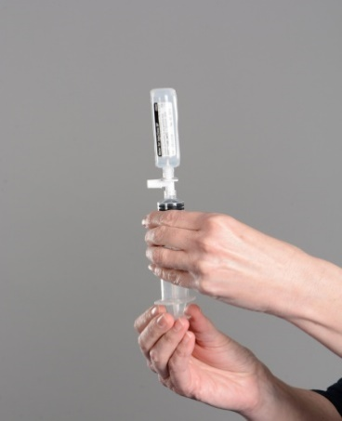
- Remove plastic cover from spike and pull plunger to loosen it
- Push spike and syringe firmly into water ampoule
- Withdraw water from ampoule into syringe by pulling plunger
- Remove ampoule of water
- Remove air and check correct amount of water for injection is in syringe
- Open ampoule of water for injection
- Open 20ml syringe (leave syringe in packet)
- Open mini spike
- Remove blue cap from spike
- Attach syringe to spike

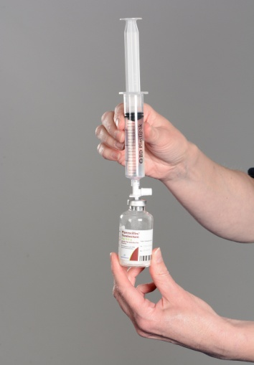
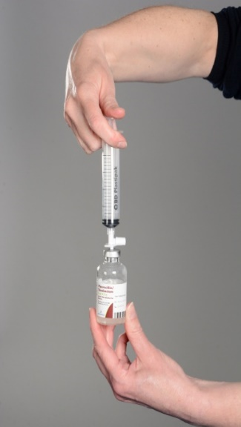

- Push spike firmly into vial of antibiotic
- Push water for injection into vial to mix antibiotic

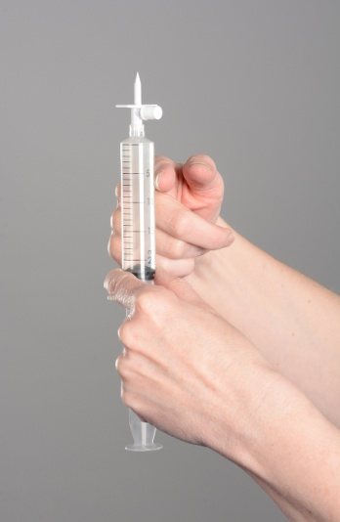
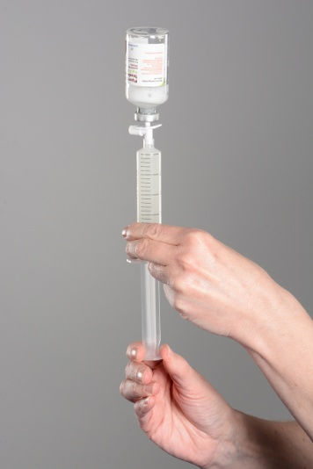
- Do not remove spike
- Shake vial and syringe together to ensure that all white particles are fully mixed
- If air is present, invert the vial and push all the air in the syringe into the vial

- Pull the plunger to withdraw the entire antibiotic into the syringe and remove bottle
- Ensure all the air is expelled from the syringe and tap the syringe to remove any air bubbles
- Attach cover onto spike before placing onto surface
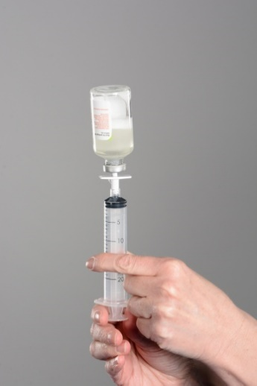
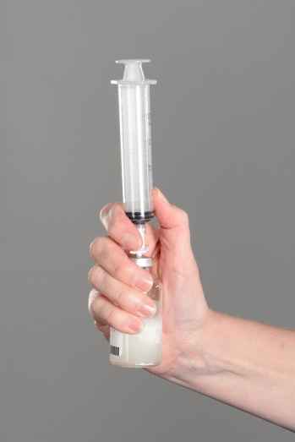

Administering IV antibiotics via a midline

Before administering IV antibiotic
Wash hands before administering antibiotic
Clean end of line thoroughly with alcohol wipe and leave to dry for 30 seconds before administering IV antibiotic.
1. Sodium Chloride: Remove white cap (keep cap clean) and attach Sodium Chloride syringe to line, release clamp, push/ pause 5mls of Sodium Chloride. Close clamp and disconnect syringe and re-attach the cap.
2. Antibiotic: Remove spike and discard, attach antibiotic syringe to line, open clamp, and pulse the entire antibiotic over 3-4 minutes. Close clamp and disconnect syringe and discard.
3. Sodium Chloride: Remove cap and attach Sodium Chloride syringe to line, release clamp, and pulse rest of Sodium Chloride until 1ml is left in syringe. Close clamp while pushing in last 1ml of sodium chloride and disconnect syringe.

Piperacillin Tazobactam 4.5g

Teaching video on intravenous antibiotics available at: www.bronchiectasis.scot.nhs.uk


