Royston Wardieburn Community Centre

Click on the imbedded links below to find out any additional information you need.

The group is held within: Royston Wardieburn Community Centre, 11 Pilton Drive North, Edinburgh, EH5 1NF



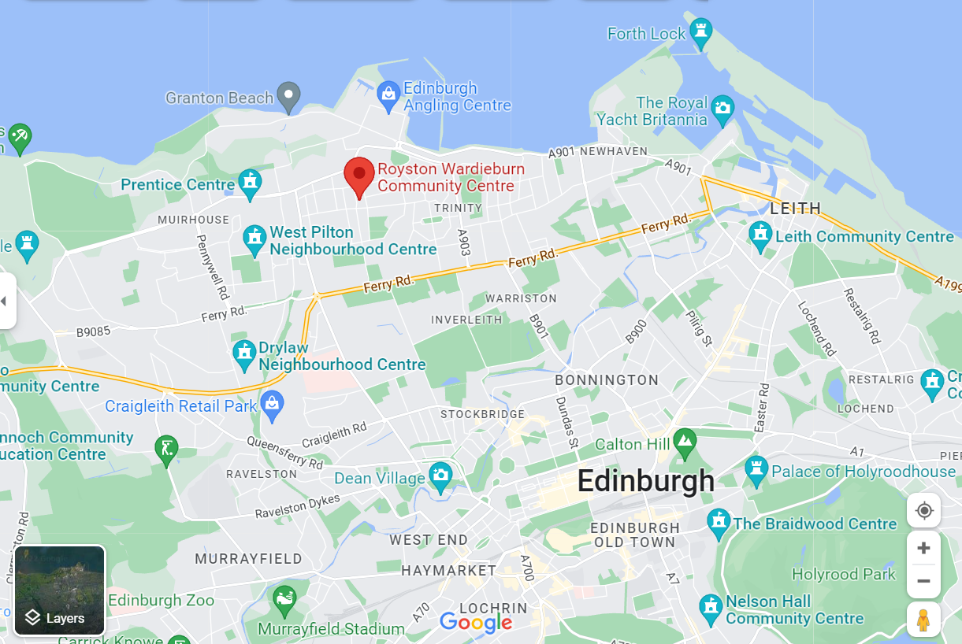
This location can be viewed through Google Maps following this link: https://goo.gl/maps/HeWHa49Z5gVQ29iz5

Public transport links: Lothian buses No 8 to Pilton Drive North (just outside centre) or 14 and 19 to Royston Mains Gardens Bus stop or Royston Mains Crescent bus stop depending on number & the direction of travel (2-minute walk to centre)

If attending this venue for a full day’s education session, please ensure you take your lunch and any drinks you will require with you.
There are no facilities within the centre for this.

