Let’s Prevent Diabetes program – Prestonpans Group Practice
(Please click on the Hyperlinks for more information)

The group is held within
Prestonpans Group Practice, Preston Road, Prestonpans, EH32 9QS

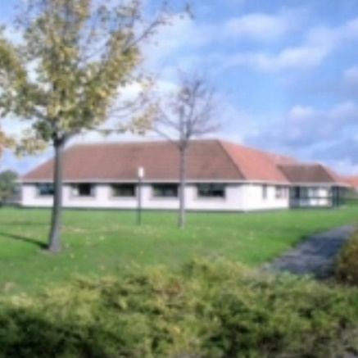

This location can be viewed through Google Maps following this link: https://goo.gl/maps/4ojEvYkh1GFpz2Fu6

Public transport links:
BUS
- Lothian Buses nos. 26,Prestonpans Health Centre Stop
- on the Clerwood / Tranent route.
- East Coast Buses 124 Prestonpans Health Centre Stop
- Prentice Buses: 111 Mercatgate Centre stop,

Train
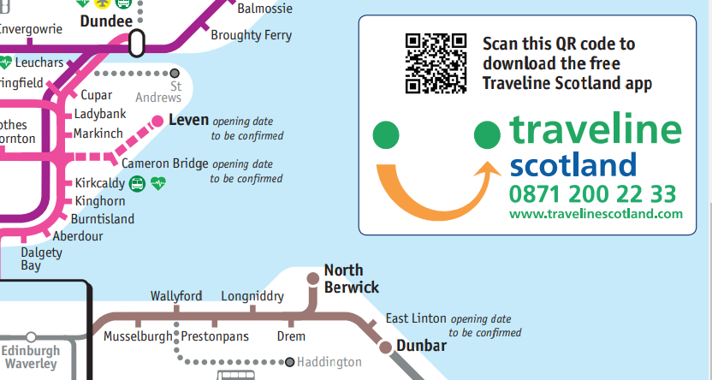

Prestonpans Train station is a short walk from the Group Practice:
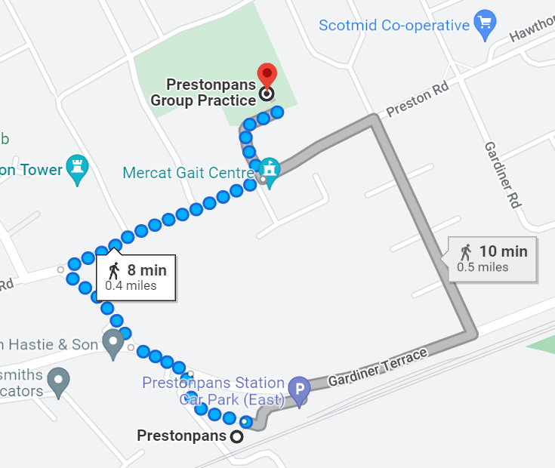

Parking
Onsite Carpark is freely available and is not reserved or pre-allocated.
Disabled parking should only be used by blue badge holders.

On arrival,
Please report to the main reception, informing the staff that you are attending to take part in the Let’s Prevent Diabetes Groups, where you will be directed towards the Practice meeting room where we will be delivering the session.

