DESMOND @ St Johns Hospital Houston Room

The group will be held within:

St Johns Hospital
Howden Road West
Howden
Livingston
West Lothian
EH54 6PP

Please make your way to the 'Houston room'. Please ask at main reception if you are unsure of the below directions:
Follow sign posts on the ground floor for 'Almond Room Education Centre'. Once on the first floor please follow signs for 'St Johns Education Centre'. Please note the education Centre is near Out Patient Dept 5.
Once in the Education Centre please follow signs for the 'Houston room'.

**Please note we will be using a room on the first floor. There is a lift, however in the event of a fire we will need to use the stairs.**

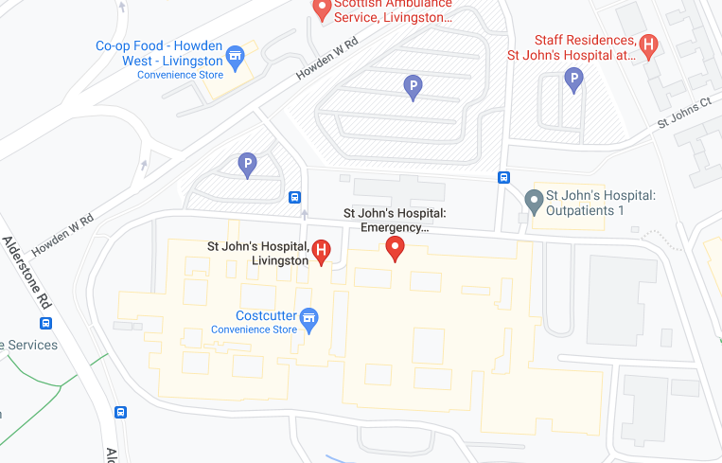

This location can be viewed through Google Maps following this link:
https://goo.gl/maps/fczvFNxjZB9NCugT8

Lothian Buses which stop at St Johns Hospital : 276, 280, x27, x28
lothianbuses.com can be used to check updates on above services, such as any changes/disruption to bus routes. The journey planner section is very useful to find out more information.

Parking is available within St Johns Hospital car parks.

