DESMOND @ Newbattle

The group will be held within:

Newbattle Medical Centre
Blackcot
Mayfield
EH22 4AA

We will be using the ‘group room’ on the first floor, please report to reception, where you will be given directions to the room.
Please note we will be using a room on the first floor. There is a lift, however in the event of a fire we need to be able to use the stairs.

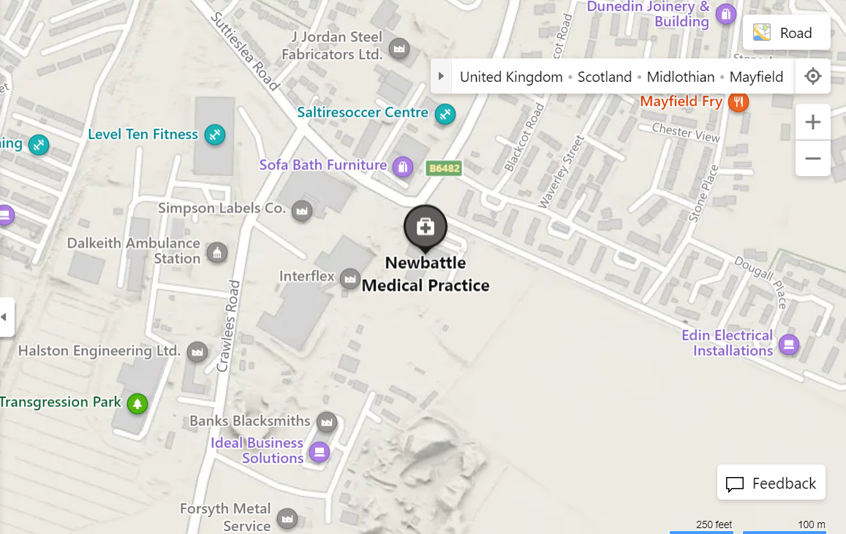
Further zoomed in map:
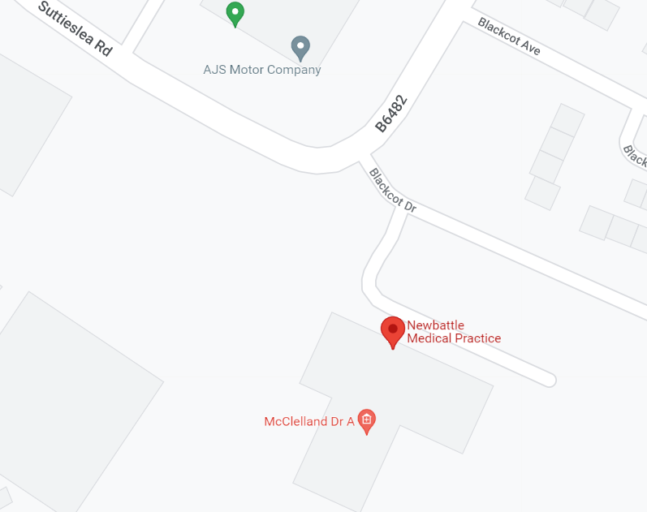
This location can be viewed through Google Maps following this link:
https://g.page/newbattle-medical-practice?share

Lothian Buses which stop on B6482 just before Blackcot Avenue junction: 48.
Lothian Buses which stop on Bogwood Road (10 minute walk to Newbattle Medical Practice): 3.
lothianbuses.com can be used to check updates on above services, such as any changes/disruption to bus routes. The journey planner section is very useful to find out more information.

Parking is available within Newbattle Medical Practice car park.

