DESMOND @ McSense

The group will be held within:

Buckie House
McSence Business Enterprise Park
32 Sycamore Road
Mayfield
EH22 5TA

Please note: If you are using a Sat Nav device or google maps to find your way, it may automatically direct you an alternative way which will not allow you into the business park. Please follow the following details.
The main entrance into the car park is from Stone Place, take the first left up a slight hill over a couple of speed bumps and through the business park gates:
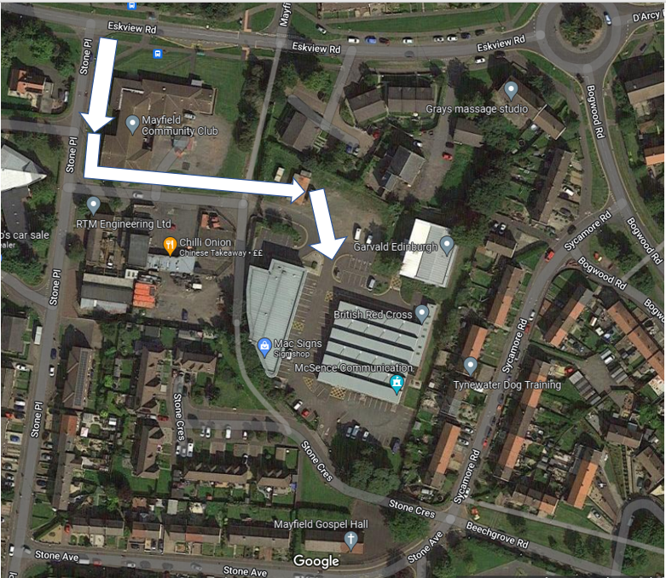

The entrance to Buckie House is located at the white cross on this map: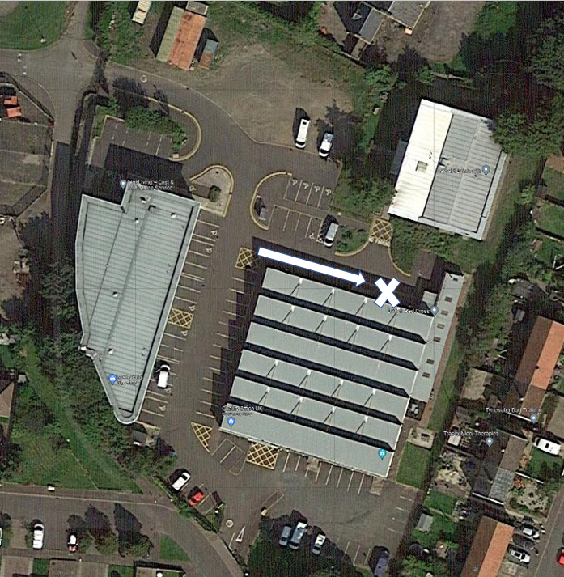
The entrance to Buckie house:
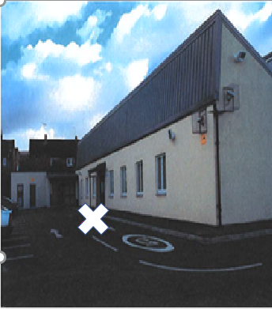

Entering the building: There is an intercom system located at the right of the main door, please simply buzz room 9 for entry. You will then be met in the reception area and guided to your room.

This location can be viewed through Google Maps following this link:
https://goo.gl/maps/pYRr17agxC9EtaS7A

Lothian Buses which stop on Eskview Road: X33 and 48.
Lothian Buses which stop on D’Arcy Road: 3
lothianbuses.com can be used to check updates on above services, such as any changes/disruption to bus routes. The journey planner section is very useful to find out more information.

Parking is available within McSense Business Park.

