DESMOND @ Leith Community Treatment Centre

The group will be held within:

Leith Community Treatment Centre
Junction Place
Edinburgh
EH6 5JQ
We will be using the ‘group room’ on the ground floor, please report to reception, where you will be given directions to the room.

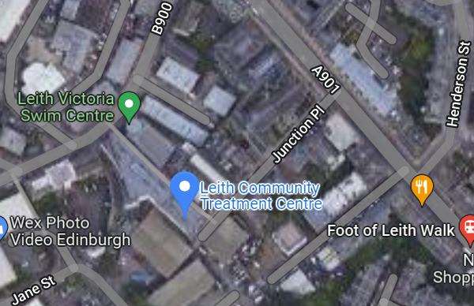

This location can be viewed through Google Maps following this link:
https://goo.gl/maps/hmxnUYk2BxnrEjTRA

Lothian Buses which stop on Junction Place : 7, 14, 21, 34, 36.
lothianbuses.com can be used to check updates on above services, such as any changes/disruption to bus routes. The journey planner section is very useful to find out more information.

Limited parking is available within Leith Community treatment centre car park, and free on street parking is also available around the centre.

