DESMOND @ East Lothian Community Hospital

The group will be held within:

East Lothian Community Hospital
Alderston Road
Haddington EH41 3PF
The room we are using is the ‘community hall’, please report to reception at the main entrance where you will be given directions.

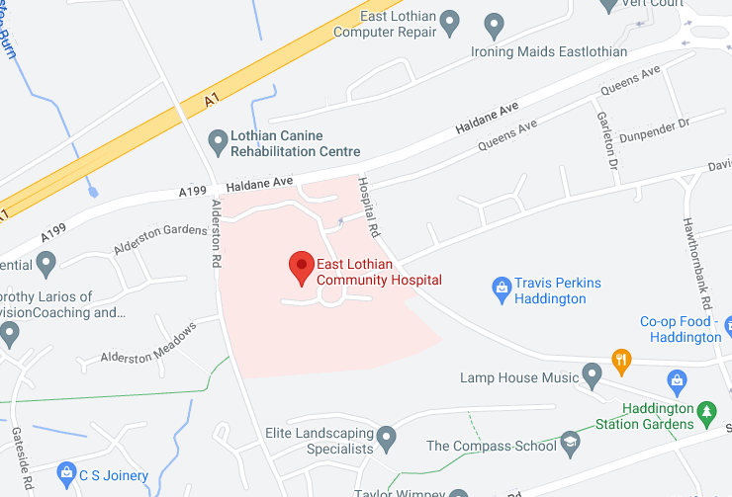

This location can be viewed through Google Maps following this link:
https://goo.gl/maps/SSwVtaBQsGBB5xh87

Lothian Buses which stop on West Road B6471 (10 minute walk from East Lothian community Hospital) : 106, X6, X7
lothianbuses.com can be used to check updates on above services, such as any changes/disruption to bus routes. The journey planner section is very useful to find out more information.

Parking is available at East Lothian Community Hospital.

