DESMOND @ Xcite Craigswood

The group will be held within:

Xcite Craigswood
Craigswood
Livingston
EH54 5ER
Please report to reception at the main entrance, where you will be given directions to the room.

Please note we will be using a room on the first floor. There is a lift, however in the event of a fire we will need to use the stairs or ramp to exit the building.

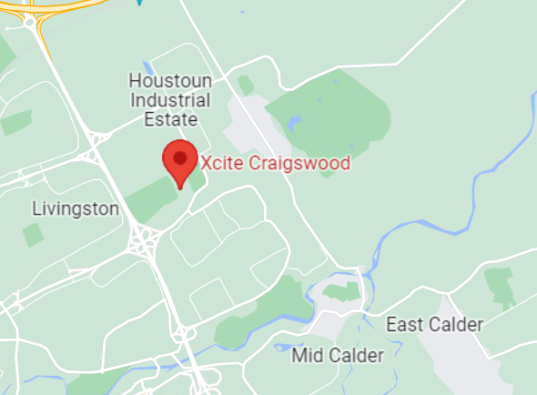
Further zoomed in map:
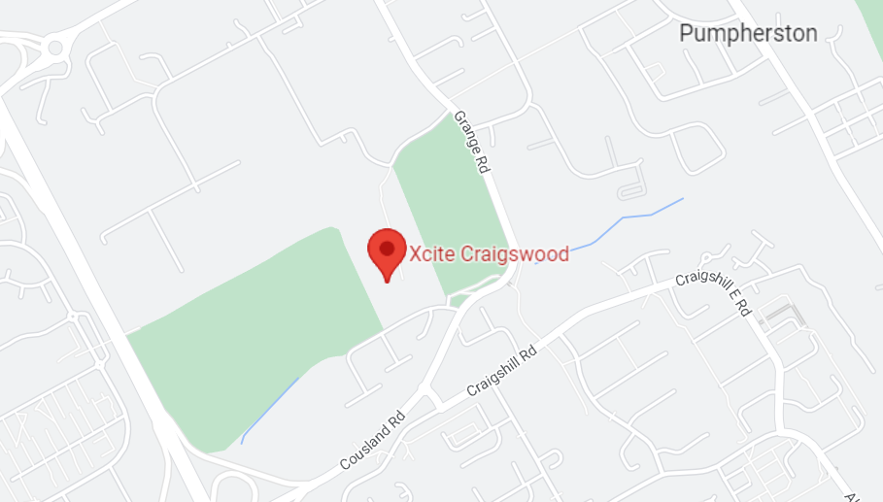

This location can be viewed through Google Maps following this link:
https://goo.gl/maps/pqr9Q9gZbjYue925A

Lothian Buses which stop nearby at various locations: X27, X28, 276
lothianbuses.com can be used to check updates on above services, such as any changes/disruption to bus routes. The journey planner section is very useful to find out more information.

Parking is freely available on-site and is not reserved or pre-allocated. Disabled parking should be used by blue badge holders only. Please do not park in surrounding residential parking bays.

